

**SCHOOL OF ENGINEERING & TECHNOLOGY**

**COURSE FILE**

Program: Electronics and Computer Engineering

Course Code: ABC1404

Course Title: Seminar/Case Studies  
Module Semester: 5th

Session: 2024-25

**Index**

|  |  |
| --- | --- |
| **S. No.** | **Topics** |
| **1.** | Course Details: Course-Code; Course Title; Semester/Term/Module; Year |
| **2.** | Vision, Mission of the University |
| **3.** | Graduate Attributes of the BMU Students |
| **4.** | Vision, Mission of the School |
| **5.** | PEOs and POs & PSOs of the Program |
| **6** | Course Description and its objectives |
| **7** | Course Outcomes and CO-PO Mapping |
| **8** | Course Syllabus: (including Course Content with Module-wise teaching hours allocated; Readings, Activities, Teaching Strategy, and Module mapped to COs, Text Book(s), Reference Books, Other learning resources) |
| **9** | Detailed Session wise Plan |
| **10** | Weekly Timetable |
| **11** | Registered Students List |
| **12** | Details of Internal Assessments; weightages, due dates, mapping to CO |
| **13** | Mid Semester Question papers with sample solutions |
| **14** | Sample Evaluated Internal Submissions and Identification of weak students. |
| **15** | Reflections from the Mid-term semester feedback received, and interventions made to enhance the student learning and continuous improvement in teaching and learning strategies. |

|  |  |
| --- | --- |
| **16** | Interventions made for slow performers and advanced learners, highlighting initiatives taken for student improvements (retest, resubmissions etc.) |
| **17** | End Semester Question papers with sample solutions |
| **18** | Detail of Marks in all components up to the End Semester |
| **19** | Attendance Report |
| **20** | Final record of Results (including the grades) |
| **21** | Analyzing Direct Feedback received on Course Outcomes |
| **22** | CO Attainment Measurement Analysis |
| **23** | Interventions made for slow performers and advanced learners, highlighting initiatives taken for student improvements (retest, resubmissions etc.) |
| **24** | End Semester Question papers with sample solutions |
| **25** | Feedback (class committee or otherwise) and corrective actions (if any) |
| **26** | Faculty Course Review (if any, like Use of Innovative Pedagogies; Technology; Experiential Learning; Integration with the Vision and Mission of the University; Feedback; Course Outcome attainment for the next run of the course) |
| **27** | Any other additional information |

# Course Details

* + Course Code: ABC1404
  + Course Title: Seminar/Case Studies

## Module/Semester: 5th

* + Session: 2024-25

# Vision, Mission of the University

## Vision

BML Munjal University seeks to nurture ethical leaders who are skilled, knowledgeable and have the life skills required for leading their organizations to success. The university shall seek the advancement and dissemination of practically oriented knowledge benchmarked with the best global standards.

## Mission

BML Munjal University aims to be a leading university for the quality and impact of its teaching, research and linkages with major stakeholders. The focus of the university is to find creative solutions to problems through application of knowledge. The university aims to create a talented community of students and faculty who excel in teaching, learning and research, in a creative and stimulating environment. The university will collaborate with other institutions for development of science, technology and arts in the global context.

# Graduate Attributes

* + Acquire and apply practical understanding of discipline knowledge.
  + Demonstrate a sense of ethics and display excellence in both personal and professional life.
  + Exhibit problem solving, critical thinking skills and investigative capability to address real world problems.
  + Manifest leadership qualities and work effectively in teams across globally diverse environments.
  + Be a lifelong learner with an entrepreneurial mindset to innovate in the constantly changing global scenario.
  + Possess a strong sense of inquiry and design innovative solutions for positive societal impact.
  + Be effective communicators and possess an empathetic outlook.

# Vision, Mission of the School

## Vision of School:

To be amongst the leading engineering schools of the country recognized globally for excellence in teaching and research with focus on experiential learning, innovation and entrepreneurship.

## Mission of School:

* Providing high-quality learning experience to our students, preparing them to be global leaders, and contributing to the development of society through research, innovation, and entrepreneurship.
* Creating an inclusive and diverse learning environment that fosters creativity, critical thinking, and ethical values.
* Collaborating with industry, government, and other institutions to address complex societal challenges and promote sustainable development.

# 5. PEOs and POs of the Program

# Program Educational Objectives (PEO):

# PEO 1 – Domain knowledge:

# Exhibit strong knowledge of the management discipline in a global context.

# PEO 2 – Informed Decision Making:

# Demonstrate higher order critical thinking and problem-solving capabilities with an entrepreneurial mindset.

# PEO 3 – Managerial Skills:

# Be effective managers with good communication skills, high levels of emotional intelligence, and innovative thinking.

# PEO 4 – Exhibit Leadership:

# Possess ethical leadership qualities for effective management decisions.

# Program Outcomes (PO):

# PO 1 –Apply Business knowledge:

# Gain in depth understanding of various management disciplines and apply the concepts for business decision making.

# PO 2 –Diverse Perspective:

# Integrate diversity and multidisciplinary perspectives in business decisions making.

# PO 3 –Cognitive Skills:

# Utilize quantitative and qualitative methods to investigate and solve complex business problems by planning and conducting research for Investigation with critical thinking and problem-solving skills.

# PO 4 –Innovation and Entrepreneurship:

# Apply relevant and creative frameworks across multiple disciplines to create innovative and entrepreneurial solutions.

# PO5 – Lead empathetic and ethical leadership:

# Demonstrate social responsibility, teamwork, life skills to lead organizations ethically.

# PO6 – Effective Communication for Impact:

# Communicate effectively across all levels and society at large.

# 6. Course Description and its objectives

The main objective of this course is to introduce students to different data structures and illustrate their effective use in solving technical and logical problems. The course comprehensively explores different problem-solving techniques and skills. Proficiency in problem-solving skills is a fundamental expectation for any competent developer, as these concepts are commonly assessed by reputable companies during the screening process for software developer positions. The primary emphasis will be on achieving a deep understanding of data structures, their implementation, practical applications through problem-solving scenarios, exploring various programming paradigms, algorithm analysis, and the practical application of different data structures and algorithms. This course explores the fundamental workings of algorithms and data structures, which lie at its core essence.

# 7. Course Outcomes and CO-PO Mapping

**Course Outcomes:**

CO1:

CO2:

CO3:

**CO/PO Mapping:**

|  |  |  |  |  |  |  |
| --- | --- | --- | --- | --- | --- | --- |
| Course Outcomes (CO) | PO1 | PO2 | PO3 | PO4 | PO5 | PO6 |
| CO1 |  |  | 2 | 2 | 2 |  |
| CO2 |  |  |  |  |  |  |
| CO3 |  | 3 | 3 | 2 |  |  |

# 8. Course Syllabus

|  |  |  |  |
| --- | --- | --- | --- |
| **Sr. No.** | **Content** | **CO** | **Sessions** |
| 1 | Linear Search, Maximum in an Array, Sorting(Selection, Bubble and Insertion), Binary search, Kadane's Algo-O(N), Merge two sorted arrays, Rotate Array anti clock wise by k times, Unique Number-1, and tell about bitwise operators, Basics of strings, String methods, String builder, Mutable and Immutable concepts, 2D Arrays: Wave Print, Spiral Print, and Transpose | 1 | 1 |
| 2 | Recursion: Factorial, Fibonacci, isArraySorted, SumofArray, Print Numbers â€“ 1) Increasing Order 2) Decreasing Order, MergeSort, Subsequence, Rat in Maze, N_Stairs, Subset Sum | 2 | 1 |
| 3 | Stack: stack implementation, Queue implementation, Linkedlist implementation(Add and Delete), Mid (Cycle detection hints), Reverse LinkedList, Merge two Sorted LinkedList, Intersection of two LinkedList, Binary Tree implementation and traversal of binary tree(PreOrder, InOrder and PostOrder), Diameter-O(N^2) and O(N) height, count number of node, Level-Order, Create Tree using Pre and Inorder, Create Tree using level-order, Binary Search Tree implementation, Addition and Deletion | 2 | 1 |
| 4 | BST to LinkedList, Balanced binary Tree, Valid BST, priority queue Collections, Kth Smallest, Meeting Room-2, Merge k Sorted List, Map and Set Collections (HashMap TreeMap and LinkedHashMap), SubArray using Map related Question | 3 | 1 |
| 5 | Dynamic Programming: Fib, min Steps to one, coin Changes, LCS, LIS, knapsack, Edit Distance, Graph basic, BFS, DFS, Dijkstra, MST(Prims), bipartite | 1 | 1 |

# 9. Learning Resources

## **Text Books:**

✓ Cracking the Coding Interview author( Gayle Laakmann McDowell )

✓ Coding Interview Questions author(Narasimha Karumanchi)

## **Reference Links:**

• https://google.com/

• NPTEL Data Structures And Algorithms, IIT Delhi

# 10. Weekly Timetable

|  |  |  |  |
| --- | --- | --- | --- |
| **Day** | **Start Time** | **End Time** | **Duration (hrs)** |
| Monday | 11:00 AM | 12:00 PM | 1 |
| Monday | 12:00 PM | 4:00 PM | 4 |

**Weekly Overview**

|  |  |  |  |  |  |  |
| --- | --- | --- | --- | --- | --- | --- |
| **Monday** | **Tuesday** | **Wednesday** | **Thursday** | **Friday** | **Saturday** | **Sunday** |
| **11:00 AM - 12:00 PM**  ABC1404 (1hr)  **12:00 PM - 4:00 PM**  ABC1404 (4hr) | *No class* | *No class* | *No class* | *No class* | *No class* | *No class* |

# 11. Registered Students List

|  |  |  |  |
| --- | --- | --- | --- |
| **Sr. No.** | **Roll No** | **Student Name** | **Unique Id** |
| 1 | 220C2030001 | Aditya Goel | 240334 |
| 2 | 220C2030002 | Anisha Chhanpadia | 240335 |
| 3 | 220C2030003 | Dhruv Singla | 240336 |
| 4 | 220C2030004 | Dorjee Phinjo Sona | 240337 |
| 5 | 220C2030005 | EENA CHAUDHARY | 240338 |
| 6 | 220C2030006 | Eshaan Chandra | 240339 |
| 7 | 220C2030007 | Hardik Rustagi | 240340 |
| 8 | 220C2030008 | Harsh Gupta | 240341 |
| 9 | 220C2030009 | Jiya Gera | 240342 |
| 10 | 220C2030010 | Keshav Gupta | 240343 |
| 11 | 220C2030011 | Luvisha Verma | 240345 |
| 12 | 220C2030012 | Mehal Raghav | 240346 |
| 13 | 220C2030013 | Neha Raju Shinde | 240347 |
| 14 | 220C2030014 | Priya Chadda | 240348 |
| 15 | 220C2030015 | Purnendu Vashishtha | 240349 |
| 16 | 220C2030016 | Sagar Bista | 240350 |
| 17 | 220C2030017 | Shoryaveer Singh | 240351 |
| 18 | 220C2030018 | Yash Garg | 240352 |
| 19 | 220C2030019 | Sanchi Narang | 240870 |
| 20 | 220C2030020 | Cheshtha Narang | 240871 |
| 21 | 220C2030021 | Nishtha Arora | 240909 |
| 22 | 220C2030022 | Astha Jaiswal | 240794 |
| 23 | 220C2030023 | Kshitij Khera | 240333 |
| 24 | 220C2030024 | Hitansh Goel | 240943 |
| 25 | 220C2030025 | Sneha Singh | 240963 |

# 19. Attendance Report

|  |  |  |  |
| --- | --- | --- | --- |
| **Sr. No.** | **Roll No** | **Student Name** | **Attendance Out of(100)** |
| 1 | 220C2030001 | Aditya Goel | 75.00 |
| 2 | 220C2030002 | Anisha Chhanpadia | 85.19 |
| 3 | 220C2030003 | Dhruv Singla | 71.43 |
| 4 | 220C2030004 | Dorjee Phinjo Sona | 89.29 |
| 5 | 220C2030005 | EENA CHAUDHARY | 100.00 |
| 6 | 220C2030006 | Eshaan Chandra | 85.71 |
| 7 | 220C2030007 | Hardik Rustagi | 78.57 |
| 8 | 220C2030008 | Harsh Gupta | 82.14 |
| 9 | 220C2030009 | Jiya Gera | 92.86 |
| 10 | 220C2030010 | Keshav Gupta | 75.00 |
| 11 | 220C2030011 | Luvisha Verma | 92.86 |
| 12 | 220C2030012 | Mehal Raghav | 81.48 |
| 13 | 220C2030013 | Neha Raju Shinde | 89.29 |
| 14 | 220C2030014 | Priya Chadda | 85.19 |
| 15 | 220C2030015 | Purnendu Vashishtha | 96.43 |
| 16 | 220C2030016 | Sagar Bista | 96.43 |
| 17 | 220C2030017 | Shoryaveer Singh | 60.71 |
| 18 | 220C2030018 | Yash Garg | 71.43 |
| 19 | 220C2030019 | Sanchi Narang | 96.43 |
| 20 | 220C2030020 | Cheshtha Narang | 96.43 |
| 21 | 220C2030021 | Nishtha Arora | 100.00 |
| 22 | 220C2030022 | Astha Jaiswal | 42.86 |
| 23 | 220C2030023 | Kshitij Khera | 78.57 |
| 24 | 220C2030024 | Hitansh Goel | 82.14 |
| 25 | 220C2030025 | Sneha Singh | 82.14 |

# 18, 20 Detail of Marks in all components up to the End Semester

|  |  |  |  |  |  |  |  |  |  |
| --- | --- | --- | --- | --- | --- | --- | --- | --- | --- |
| **Sr. No.** | **Roll No** | **Student Name** | **Assignment**  **Out** | **End term examination**  **Out** | **Group Presentation**  **Out** | **Individual Class Participation**  **Out** | **Mid Term Exam**  **Out** | **Role Play**  **Out** | **Total Marks(100.0)**  **Out** |
| 1 | 220C2030001 | Aditya Goel | 8.5 | 0.0 | 9.0 | 0.0 | 6.5 | 8.0 | 32.00 |
| 2 | 220C2030002 | Anisha Chhanpadia | 8.5 | 21.0 | 9.0 | 9.0 | 10.5 | 8.0 | 66.00 |
| 3 | 220C2030003 | Dhruv Singla | 8.5 | 24.0 | 9.0 | 1.0 | 6.0 | 8.0 | 56.50 |
| 4 | 220C2030004 | Dorjee Phinjo Sona | 8.5 | 18.5 | 9.0 | 7.0 | 3.0 | 8.0 | 54.00 |
| 5 | 220C2030005 | EENA CHAUDHARY | 9.0 | 29.0 | 9.0 | 8.5 | 8.0 | 8.0 | 71.50 |
| 6 | 220C2030006 | Eshaan Chandra | 7.5 | 26.0 | 8.5 | 6.0 | 8.0 | 7.5 | 63.50 |
| 7 | 220C2030007 | Hardik Rustagi | 9.0 | 21.0 | 8.5 | 7.5 | 4.5 | 7.5 | 58.00 |
| 8 | 220C2030008 | Harsh Gupta | 8.0 | 20.0 | 7.5 | 0.0 | 7.5 | 8.0 | 51.00 |
| 9 | 220C2030009 | Jiya Gera | 8.5 | 26.5 | 8.5 | 7.5 | 8.5 | 8.0 | 67.50 |
| 10 | 220C2030010 | Keshav Gupta | 7.5 | 5.0 | 8.5 | 0.0 | 4.0 | 8.0 | 33.00 |
| 11 | 220C2030011 | Luvisha Verma | 8.0 | 20.0 | 7.5 | 9.5 | 7.5 | 7.0 | 59.50 |
| 12 | 220C2030012 | Mehal Raghav | 8.0 | 30.0 | 7.5 | 3.0 | 4.0 | 7.0 | 59.50 |
| 13 | 220C2030013 | Neha Raju Shinde | 8.5 | 20.5 | 8.5 | 6.0 | 6.0 | 7.5 | 57.00 |
| 14 | 220C2030014 | Priya Chadda | 9.0 | 34.0 | 8.5 | 6.5 | 16.0 | 8.0 | 82.00 |
| 15 | 220C2030015 | Purnendu Vashishtha | 8.0 | 11.5 | 8.0 | 6.5 | 8.0 | 7.0 | 49.00 |
| 16 | 220C2030016 | Sagar Bista | 9.5 | 23.0 | 8.0 | 7.5 | 12.0 | 7.0 | 67.00 |
| 17 | 220C2030017 | Shoryaveer Singh | 8.0 | 21.5 | 0.0 | 1.0 | 2.5 | 7.0 | 40.00 |
| 18 | 220C2030018 | Yash Garg | 8.0 | 5.0 | 7.0 | 0.0 | 2.5 | 8.0 | 30.50 |
| 19 | 220C2030019 | Sanchi Narang | 9.5 | 35.0 | 8.0 | 9.5 | 17.0 | 8.0 | 87.00 |
| 20 | 220C2030020 | Cheshtha Narang | 7.5 | 33.0 | 9.0 | 9.5 | 8.0 | 8.0 | 75.00 |
| 21 | 220C2030021 | Nishtha Arora | 8.5 | 18.5 | 7.5 | 8.5 | 17.5 | 8.0 | 68.50 |
| 22 | 220C2030022 | Astha Jaiswal | 0.0 | 0.0 | 0.0 | 0.0 | 0.0 | 0.0 | 0.00 |
| 23 | 220C2030023 | Kshitij Khera | 9.5 | 15.5 | 7.5 | 4.5 | 8.5 | 7.0 | 52.50 |
| 24 | 220C2030024 | Hitansh Goel | 8.0 | 11.5 | 7.5 | 4.0 | 3.5 | 8.0 | 42.50 |
| 25 | 220C2030025 | Sneha Singh | 8.0 | 26.5 | 8.0 | 5.5 | 9.5 | 8.0 | 65.50 |

# 12. CO Attainment Analysis

## CO Attainment Summary

|  |  |  |  |
| --- | --- | --- | --- |
| **Course Outcomes** | **CO1** | **CO2** | **CO3** |
| Weights | 55.00% | 21.00% | 24.00% |
| No. of students scored greater than 3 | 2 | 4 | 4 |
| Percentage of students scored greater than 3 | 8.00% | 16.00% | 16.00% |
| Attainment Level | 1 | 1 | 1 |
| **Overall Course Attainment** | **1.0000** | | |

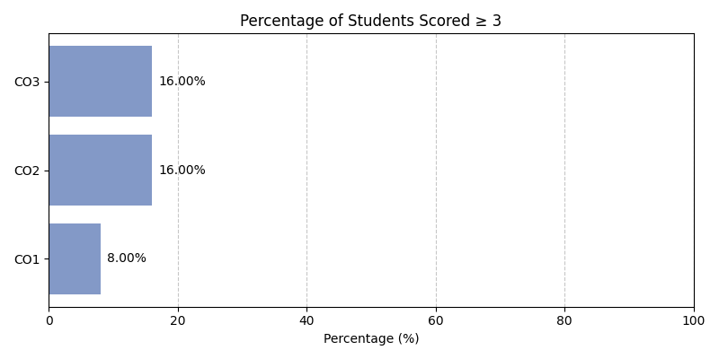

## Program Attainment

|  |  |  |  |  |  |  |
| --- | --- | --- | --- | --- | --- | --- |
| **Program Outcomes** | **PO1** | **PO2** | **PO3** | **PO4** | **PO5** | **PO6** |
| Program Attainment | 0.00 | 1.32 | 1.26 | 1.24 | 1.16 | 0.00 |

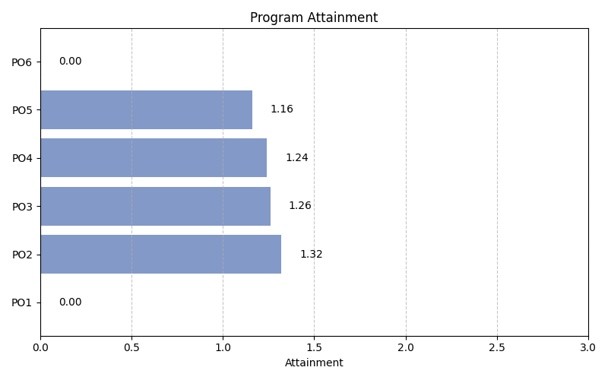

## Student-wise CO Achievement

|  |  |  |  |
| --- | --- | --- | --- |
| **NAME** | **CO1 Score** | **CO2 Score** | **CO3 Score** |
| Aditya Goel | 1 | 1 | 1 |
| Anisha Chhanpadia | 1 | 1 | 1 |
| Dhruv Singla | 1 | 1 | 1 |
| Dorjee Phinjo Sona | 1 | 1 | 1 |
| EENA CHAUDHARY | 1 | 3 | 3 |
| Eshaan Chandra | 1 | 1 | 1 |
| Hardik Rustagi | 1 | 1 | 1 |
| Harsh Gupta | 1 | 1 | 1 |
| Jiya Gera | 1 | 1 | 1 |
| Keshav Gupta | 1 | 1 | 1 |
| Luvisha Verma | 1 | 1 | 1 |
| Mehal Raghav | 1 | 1 | 1 |
| Neha Raju Shinde | 1 | 1 | 1 |
| Priya Chadda | 3 | 3 | 3 |
| Purnendu Vashishtha | 1 | 1 | 1 |
| Sagar Bista | 1 | 1 | 1 |
| Shoryaveer Singh | 1 | 1 | 1 |
| Yash Garg | 1 | 1 | 1 |
| Sanchi Narang | 3 | 3 | 3 |
| Cheshtha Narang | 1 | 3 | 3 |
| Nishtha Arora | 1 | 1 | 1 |
| Astha Jaiswal | 1 | 1 | 1 |
| Kshitij Khera | 1 | 1 | 1 |
| Hitansh Goel | 1 | 1 | 1 |
| Sneha Singh | 1 | 1 | 1 |
| **Average** | **1.16** | **1.32** | **1.32** |

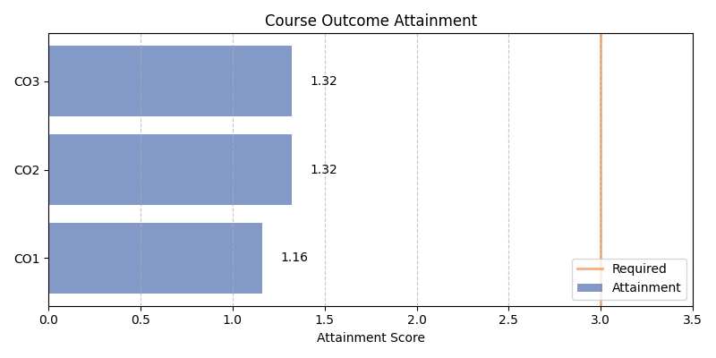

# 13. Student Learning Categories

## Learner Categories Summary

|  |  |
| --- | --- |
| **Learner Category** | **Number of Students** |
| Advanced Learners | 2 |
| Medium Learners | 2 |
| Slow Learners | 21 |

## Student Learning Classification

|  |  |  |  |  |
| --- | --- | --- | --- | --- |
| **Student Name** | **Category** | **CO1** | **CO2** | **CO3** |
| Priya Chadda | Advanced Learner | 3 | 3 | 3 |
| Sanchi Narang | Advanced Learner | 3 | 3 | 3 |
| EENA CHAUDHARY | Medium Learner | 1 | 3 | 3 |
| Cheshtha Narang | Medium Learner | 1 | 3 | 3 |
| Aditya Goel | Slow Learner | 1 | 1 | 1 |
| Anisha Chhanpadia | Slow Learner | 1 | 1 | 1 |
| Dhruv Singla | Slow Learner | 1 | 1 | 1 |
| Dorjee Phinjo Sona | Slow Learner | 1 | 1 | 1 |
| Eshaan Chandra | Slow Learner | 1 | 1 | 1 |
| Hardik Rustagi | Slow Learner | 1 | 1 | 1 |
| Harsh Gupta | Slow Learner | 1 | 1 | 1 |
| Jiya Gera | Slow Learner | 1 | 1 | 1 |
| Keshav Gupta | Slow Learner | 1 | 1 | 1 |
| Luvisha Verma | Slow Learner | 1 | 1 | 1 |
| Mehal Raghav | Slow Learner | 1 | 1 | 1 |
| Neha Raju Shinde | Slow Learner | 1 | 1 | 1 |
| Purnendu Vashishtha | Slow Learner | 1 | 1 | 1 |
| Sagar Bista | Slow Learner | 1 | 1 | 1 |
| Shoryaveer Singh | Slow Learner | 1 | 1 | 1 |
| Yash Garg | Slow Learner | 1 | 1 | 1 |
| Nishtha Arora | Slow Learner | 1 | 1 | 1 |
| Astha Jaiswal | Slow Learner | 1 | 1 | 1 |
| Kshitij Khera | Slow Learner | 1 | 1 | 1 |
| Hitansh Goel | Slow Learner | 1 | 1 | 1 |
| Sneha Singh | Slow Learner | 1 | 1 | 1 |

# 14. Actions taken for weak students

• we beat them

# 15. Student Feedback

**Quantitative Feedback:**

Average Rating: 4.37/5

**Qualitative Feedback:**

course was good

# 16. Faculty Course Review

lol this field never was suppose to even work how did it work good question!!!!!